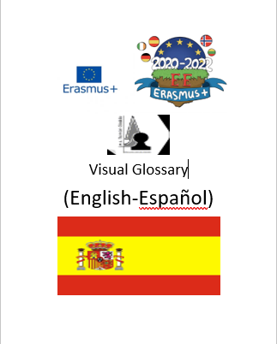

**Visual Glossary**

Introduction:

This visual glossary, designed by the Erasmus+ classes of Norway, Ireland, Lithuania, Spain and Germany is a glossary of key terms and phrases that would be of use in our project, Europe Evolving and in our everyday lives. The glossary is in each country’s respective language along with English, so every person who looks at this glossary can develop a deeper understanding of the terms and phrases with images to help identify them. This glossary has been composed in a way that makes it easily accessible and understandable for all including those with learning difficulties and additional needs.

|  |  |  |
| --- | --- | --- |
| **Term** | **Picture** | **Spanish** |
| **Art** |  | **Arte** |
| **Archeology** |  | **Arqueología** |
| **Artefact** |  | **Artefacto** |
| **Audio** |  | **Audio** |
| **Creativity** |  | **Creatividad** |
| **Community** |  | **Comunidad** |
| **Covid 19** |  | **Covid 19** |
| **Cultures** |  | **Culturas** |
| **Diary** |  | **Diario** |
| **Dig** |  | **Cavar** |
| **Diversity** |  | **Diversidad** |
| **Europe** |  | **Europa** |
| **Exchange** |  | **Intercambio** |
| **Extinction** |  | **Extinción** |
| **Evidence** |  | **Evidencia, prueba** |
| **Fake News** |  | **Noticias falsas** |
| **Future** |  | **Futuro** |
| **Friendships** |  | **Amistades** |
| Goal  cúl |  | **Objetivos** |
| **Germany** |  | **Alemania** |
| **Global warming** |  | **Calentamiento global** |
| **History** |  | **Historia** |
| **Idea** |  | **Idea** |
| **Internet** |  | **Internet** |
| **Ireland** |  | **Irlanda** |
| **Isolation** |  | **Aislamiento** |
| **Letter** |  | **Carta** |
| **Literature** |  | **Literatura** |
| **Lithuania** |  | **Lituania** |
| **Location** |  | **Localización** |
| **Map** |  | **Mapa** |
| **Mask** |  | **Mascarilla** |
| **Museum** |  | **Museo** |
| **Music** |  | **Música** |
| **Newspaper** |  | **Periódico** |
| **Norway** |  | **Noruega** |
| **Online** |  | **En línea** |
| **Past** |  | **Pasado** |
| **Pandemic** |  | **Pandemia** |
| **Plant** |  | **Planta** |
| **Present** |  | **Presente** |
| **Presentation** |  | **Presentación** |
| **Project** |  | **Proyecto** |
| **Restrictions** |  | **Restricciones** |
| **Share** |  | **Compartir** |
| **Social distancing** |  | **Distanciamiento social** |
| **Social media** |  | **Redes sociales** |
| **Sport** |  | **Deporte** |
| **Spain** |  | **España** |
| **Students** |  | **Alumnos** |
| **Sustainability** |  | **Sostenibilidad** |
| **Teacher** |  | **Professor** |
| **Teamwork** |  | **Trabajo en equipo** |
| **Technology** |  | **Tecnología** |
| **Team** |  | **Equipo** |
| **Time capsule** |  | **Cápsula del tiempo** |
| **Together** |  | **Juntos** |
| **Travel** |  | **Viajar** |
| **Tree** |  | **Árbol** |
| United Nations |  | **Naciones Unidas** |
| **Virus** |  | **Virus** |
| **Virtual** |  | **Virtual** |
| **Visual** |  | **Visual** |
| **Vision** |  | **Vision** |
| **Water** |  | **Agua** |
| **Written** |  | **Escrito** |