

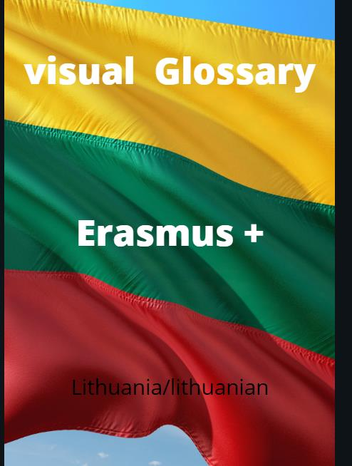

**Visual Glossary**

Introduction:

This visual glossary, designed by the Erasmus+ classes of Norway, Ireland, Lithuania, Spain and Germany is a glossary of key terms and phrases that would be of use in our project, Europe Evolving and in our everyday lives. The glossary is in each country’s respective language along with English, so every person who looks at this glossary can develop a deeper understanding of the terms and phrases with images to help identify them. This glossary has been composed in a way that makes it easily accessible and understandable for all including those with learning difficulties and additional needs.

|  |  |  |
| --- | --- | --- |
| **Term** | **Picture** | **Lithuanian** |
| **Art** |  | **Dailė/ menas** |
| **Archaeology** |  | **Archeologija** |
| **Artefact** |  | **Artefaktas** |
| **Audio** |  | **Garso įrašas** |
| **Creativity** |  | **Kūrybiškumas** |
| **Community** |  | **Bendruomenė** |
| **Covid 19** |  | **Covid-19 virusas/ Korona virusas** |
| **Cultures** |  | **Kultūros** |
| **Diary** |  | **Dienoraštis** |
| **Dig** |  | **Kasti/ kasinėjimai** |
| **Diversity** |  | **Įvairovė** |
| **Europe** |  | **Europa** |
| **Exchange** |  | **Mainai/ mainytis** |
| **Extinction** |  | **Išnykę** |
| **Evidence** |  | **Įrodymai** |
| **Fake News** |  | **Netikros naujienos** |
| **Future** |  | **Ateitis** |
| **Friendships** |  | **Draugystė** |
| Goal  cúl |  | **Tikslas** |
| **Germany** |  | **Vokietija** |
| **Global warming** |  | **Pasaulinis atšilimas** |
| **History** |  | **Istorija** |
| **Idea** |  | **Idėja** |
| **Internet** |  | **Internetas** |
| **Ireland** |  | **Airija** |
| **Isolation** |  | **Atskirtis/ izoliacija** |
| **Letter** |  | **Laiškas** |
| **Literature** |  | **Literatūra** |
| **Lithuania** |  | **Lietuva** |
| **Location** |  | **Vietovė** |
| **Map** |  | **Žemėlapis** |
| **Mask** |  | **Apsauginė veido kaukė** |
| **Museum** |  | **Muziejus** |
| **Music** |  | **Muzika** |
| **Newspaper** |  | **Laikraštis** |
| **Norway** |  | **Norvegija** |
| **Online** |  | **Būti pasiekiamam internete** |
| **Past** |  | **Praeitis** |
| **Pandemic** |  | **Pandemija** |
| **Plant** |  | **Augalas** |
| **Present** |  | **Dabartis** |
| **Presentation** |  | **Pristatymas** |
| **Project** |  | **Projektas** |
| **Restrictions** |  | **Apribojimai/ sugriežtinimai** |
| **Share** |  | **Dalintis** |
| **Social distancing** |  | **Saugaus atstumo laikymasis** |
| **Social media** |  | **Socialiniai tinklai** |
| **Sport** |  | **Sportas** |
| **Spain** |  | **Ispanija** |
| **Students** |  | **Mokiniai** |
| **Sustainability** |  | **Tvarumas** |
| **Teacher** |  | **Mokytoja** |
| **Teamwork** |  | **Komandinis darbas** |
| **Technology** |  | **Technologijos** |
| **Team** |  | **Komanda** |
| **Time capsule** |  | **Laiko kapsulė** |
| **Together** |  | **Kartu** |
| **Travel** |  | **Keliauti** |
| **Tree** |  | **Medis** |
| United Nations |  | **Tautų sąjunga** |
| **Virus** |  | **Virusas** |
| **Virtual** |  | **Virtualus** |
| **Visual** |  | **Vizualinis** |
| **Vision** |  | **Vizija** |
| **Water** |  | **Vanduo** |
| **Written** |  | **Parašytas** |